The GPhC register as of 31 August 2022 - Trend data

Contents
Our register 1
How to interpret our data 1
Overall register headlines 1
Register trends for pharmacists 1
Annotations to the pharmacist register 3
Register trends for pharmacy technicians 3
Register trends for pharmacies 4

Our register
We maintain a comprehensive, fully up-to-date pharmacy register of all pharmacists, pharmacy technicians and pharmacy premises. We will make sure that no-one can be identified from any data that we publish or share with others.

How to interpret our data
Our permanent register can change daily and at different times of the day. The data presented here is a snapshot of our register at 23:59:59 on the dates specified.
Please note that numbers by country are according to their registered home address. This does not necessarily mean that registrants are working in those countries or that they are in employment. This only shows that they are on the register. Where tables or figures refer to ‘All’ countries, this includes registrants with a registered address in England, Scotland, Wales, Northern Ireland, Channel Islands, Isle of Man and Overseas. Where tables refer to ‘Other’ countries, these are all countries outside of Great Britain.
The numbers of pharmacists with a prescribing annotation does not reflect how many are currently employed or working with their prescribing annotation.
We continually review our data quality and content of our information to include the most accurate calculations. For improved data, we retrospectively update figures. This means when comparing this data with previously published data, you may see small changes.

Overall register headlines
- On 31 August 2022, the total number of pharmacy professionals on the register increased by 1,400 to 87,643 from 86,243 at the end of July 2022. The split by profession type remains steady with 71% pharmacists (62,525) and 29% pharmacy technicians (25,118). Following the June 2022 registration assessment, there was an increase in the number of pharmacists joining the register by 1,424 from 61,101 at the end of July 2022. However, the number the number of pharmacy technicians fell slightly by 24 from 25,142.
- The number of pharmacists with a prescribing annotation has increased by 187 from 14,140 on 31 July 2022 to 14,327 on 31 August 2022. This represents 22.9% of registered pharmacists where the overall proportion has remained steady.
- There are 13,846 registered pharmacies on 31 August 2022, a decrease of seven from 13,853 in the last month on 31 July 2022. The numbers of pharmacies have been falling over the last eight years with a low of 13,843 pharmacies in April 2022, where numbers are fluctuating on a monthly basis.

Register trends for pharmacists
On 31 August 2022 the number of pharmacists on the register was 62,525. This is an increase of 1,424 from 61,101 at the end of July 2022. Table 1 shows the trend in the snapshot of pharmacist numbers on our register over time by location of registered address up to the end of 31 August each year for a direct comparison due to monthly variations.

Table 1: Snapshot of pharmacists on the register by location of registered address at the end of August for the last eight years
Snapshot date | All | England | Scotland | Wales
31 August 2022 | 62,525 | 52,610 | 5,436 | 2,749
31 August 2021 | 58,757 | 49,349 | 5,120 | 2,610
31 August 2020 | 57,432 | 48,164 | 4,984 | 2,584
31 August 2019 | 57,467 | 47,996 | 5,026 | 2,604
31 August 2018 | 56,543 | 46,950 | 4,963 | 2,587
31 August 2017 | 55,271 | 45,662 | 4,885 | 2,550
31 August 2016 | 53,806 | 44,310 | 4,775 | 2,491
31 August 2015 | 51,665 | 42,354 | 4,627 | 2,407
Compared to the same time last year, there is 6% increase of pharmacists by 3,768 from 58,757 on 31 August 2021 to 62,525 on 31 August 2022. This percentage increase includes joiners to the register following the postponed registration assessments in 2020.
Of the 62,525 pharmacists, 1,730 (3%) have a registered address outside of Great Britain. These include recent joiners who have yet to register an address in Great Britain. Others have left Great Britain and are overseas but would like to retain their GPhC registration or have yet to leave the register.
In Figure 1, the top teal blue line represents the total number of all pharmacists on the register at the end of each month of August (including those with a registered address in England, Scotland, Wales, Northern Ireland, Channel Islands, Isle of Man and overseas). The dark purple line are the figures for England, the green line is for Scotland and the pink line is for Wales.
Figure 1: Snapshot of pharmacists on the register at the end of August each year by registered address location
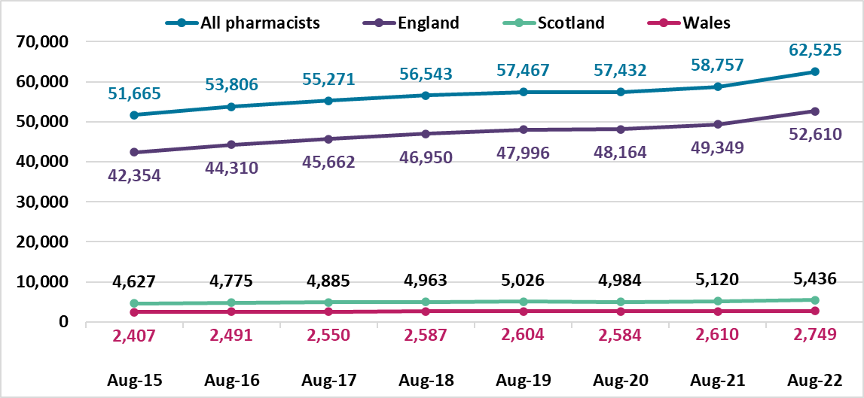

Annotations to the pharmacist register
On 31 August 2022, the number of registered pharmacists having a prescriber annotation has increased by 187 since the last month to 14,327 out of 62,525, this is 22.9% of the register. These include 13,133 independent prescribers only, 936 pharmacists who hold both independent and supplementary prescribing annotations and 258 supplementary prescribers only.
The breakdown of prescriber annotation by country of registered address is summarised in Table 2 below for pharmacists on 31 August 2022. The category of ‘Other’ includes countries that are overseas, Isle of Man, Northern Ireland and the Channel Islands. We do not know how many pharmacists are currently employed or are practising with their prescribing annotation.
Table 2: Number of pharmacists with prescribing annotation type by country of registered address on 31 August 2022
Prescriber annotation type | England | Scotland | Wales | Other | All
Independent only | 10,848 | 1,501 | 726 | 58 | 13,133
Independent and supplementary | 621 | 254 | 55 | 6 | 936
Supplementary only | 159 | 83 | 11 | 5 | 258
Total | 11,628 | 1,838 | 792 | 69 | 14,327

Register trends for pharmacy technicians
Table 3 and Figure 2 below shows the trend in pharmacy technician numbers on our register on 31 August from 2015 to 2022. This shows the register has been increasing year on year. There is a 1% increase from 24,811 in August 2021 last year to 25,118 in August 2022 this year. The number of pharmacy technicians has decreased by 24 since the last month from 25,142 in July 2022.
Table 3: Snapshot of pharmacy technicians on the register by country of registered address
Snapshot date | All | England | Scotland | Wales
31 August 2022 | 25,118 | 20,891 | 2,353 | 1,702
31 August 2021 | 24,811 | 20,657 | 2,275 | 1,706
31 August 2020 | 23,885 | 19,882 | 2,205 | 1,642
31 August 2019 | 23,563 | 19,597 | 2,166 | 1,637
31 August 2018 | 23,437 | 19,530 | 2,102 | 1,644
31 August 2017 | 23,421 | 19,530 | 2,091 | 1,636
31 August 2016 | 23,218 | 19,332 | 2,088 | 1,627
31 August 2015 | 22,893 | 19,067 | 2,050 | 1,605
For Figure 2 below, the top teal blue line represents the total number of pharmacy technicians on the register. The dark purple line is England, the green line is Scotland, and the pink line is Wales. The overall proportion of pharmacy technicians in each country has remained steady as the numbers increased over the last eight years.
Figure 2. Snapshot of pharmacy technicians at the end of August by year and registered address location
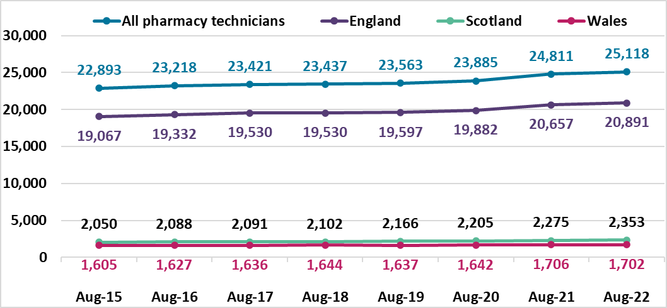

Register trends for pharmacies
On 31 August 2022 there were 13,846 registered pharmacies. 11,817 are in England, 1,303 in Scotland and 726 in Wales. This is a decrease of 115 from the same time last year, a fall of 0.8%. Table 4 shows a decrease each year. The numbers vary each month, with an increase reported last month, but in this month, there was a decrease of seven from 13,853 in July 2022.
Table 4: Snapshot of all pharmacies on the register and by country of registered address at the end of August for the last eight years
Snapshot date | All | England | Scotland | Wales
31 August 2022 | 13,846 | 11,817 | 1,303 | 726
31 August 2021 | 13,961 | 11,926 | 1,301 | 734
31 August 2020 | 14,098 | 12,063 | 1,297 | 738
31 August 2019 | 14,275 | 12,237 | 1,296 | 742
31 August 2018 | 14,342 | 12,301 | 1,293 | 748
31 August 2017 | 14,388 | 12,359 | 1,284 | 745
31 August 2016 | 14,426 | 12,391 | 1,285 | 750
31 August 2015 | 14,451 | 12,406 | 1,297 | 748
For Figure 3 below, the top teal blue line represents the total number of pharmacies on the register. The dark purple line is England, the green line is Scotland, and the pink line is Wales. The overall proportion of pharmacies in each country has remained steady.
Figure 3. Snapshot of pharmacies on the register at the end of August each year by registered address location
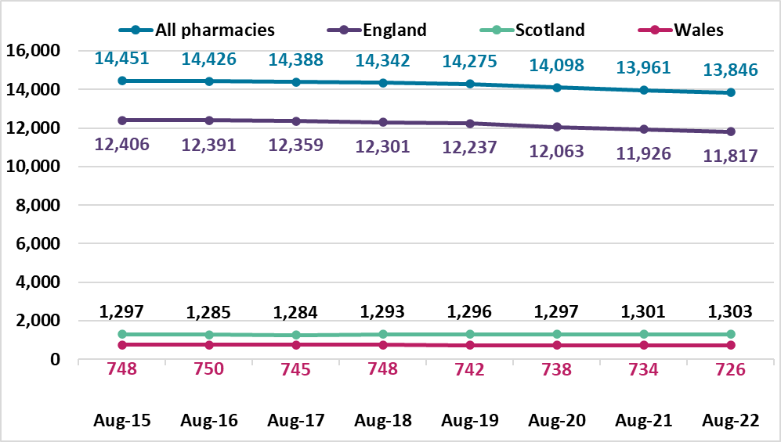

Annotations are additional qualifications or responsibilities held by a registrant. An independent prescriber can prescribe any medicine for any condition (excluding 3 Controlled Drugs for the treatment of addiction). A supplementary prescriber can prescribe any medicine for any condition within an agreed clinical management plan.

