The GPhC register as of 30 November 2022 - Trend data

Contents
Our register 1
How to interpret our data 1
Overall register headlines 1
Register trends for pharmacists 1
Annotations to the pharmacist register 3
Register trends for pharmacy technicians 3
Register trends for pharmacies 4

Our register
We maintain a comprehensive, fully up-to-date pharmacy register of all pharmacists, pharmacy technicians and pharmacy premises. We will make sure that no-one can be identified from any data that we publish or share with others.

How to interpret our data
Our permanent register can change daily and at different times of the day. The data presented here is a snapshot of our register at 23:59:59 on the dates specified.
Please note that numbers by country are according to their registered home address. This does not necessarily mean that registrants are working in those countries or that they are in employment. This only shows that they are on the register. Where tables or figures refer to ‘All’ countries, this includes registrants with a registered address in England, Scotland, Wales, Northern Ireland, Channel Islands, Isle of Man and Overseas. Where tables refer to ‘Other’ countries, these are all countries outside of Great Britain.
The numbers of pharmacists with a prescribing annotation does not reflect how many are currently employed or working with their prescribing annotation. The data does not reflect how many pharmacy professionals are currently working but how many are on the GPhC register.
We continually review our data quality and content of our information to include the most accurate calculations. For improved data, we retrospectively update figures. This means when comparing this data with previously published data, you may see small changes.

Overall register headlines
- On 30 November 2022, the total number of pharmacy professionals on the register increased by 87 to 88,131 from 88,044 at the end of October 2022. The split by profession type remains steady with 71% pharmacists (62,525) and 29% pharmacy technicians (25,279). At the end of November 2022 another 17 pharmacists have joined the register. In addition to the 75 pharmacy technicians added to the register in October 2022 the number of pharmacy technicians have increased by a further 70 by the end of November 2022.
- The number of pharmacists with a prescribing annotation has increased by 221 from 14,895 on 31 October 2022 to 15,116 on 30 November 2022. This represents 24% of registered pharmacists where the overall proportion has remained steady but increased slightly from 23% in October 2022.
- There are 13,811 registered pharmacies on 30 November 2022, a decrease of 26 from 13,837 in the last month on 31 October 2022. The numbers of pharmacies have been falling over the last eight years with a low of 13,811 pharmacies in November 2022, where numbers are fluctuating on a monthly basis.

Register trends for pharmacists
On 30 November 2022 the number of pharmacists on the register was 62,525. This is an increase of 17 from 62,835 at the end of October 2022. Table 1 shows the trend in the snapshot of pharmacist numbers on our register over time by location of registered address up to the end of 30 November each year for a direct comparison due to monthly variations.

Table 1: Snapshot of pharmacists on the register by location of registered address at the end of November for the last eight years
Snapshot date | All | England | Scotland | Wales
30 November 2022 | 62,852 | 52,885 | 5,434 | 2,751
30 November 2021 | 60,541 | 50,854 | 5,287 | 2,681
30 November 2020 | 57,250 | 48,020 | 4,983 | 2,572
30 November 2019 | 58,057 | 48,599 | 5,020 | 2,614
30 November 2018 | 57,199 | 47,619 | 4,975 | 2,585
30 November 2017 | 55,969 | 46,323 | 4,890 | 2,556
30 November 2016 | 54,683 | 45,098 | 4,809 | 2,519
30 November 2015 | 52,535 | 43,162 | 4,656 | 2,425
Compared to the same time last year, there is 3.8% increase of pharmacists by 2,311 from 60,541 on 31 November 2021 to 62,852 on 30 November 2022.
Of the 62,852 pharmacists, 1,782 (2.8%) have a registered address outside of Great Britain. These include recent joiners who have yet to register an address in Great Britain. Others have left Great Britain and are overseas but would like to retain their GPhC registration or have yet to leave the register.
In Figure 1, the top teal blue line represents the total number of all pharmacists on the register at the end of each month of November (including those with a registered address in England, Scotland, Wales, Northern Ireland, Channel Islands, Isle of Man and overseas). The dark purple line are the figures for England, the green line is for Scotland and the pink line is for Wales.
Figure 1: Snapshot of pharmacists on the register at the end of November each year by registered address location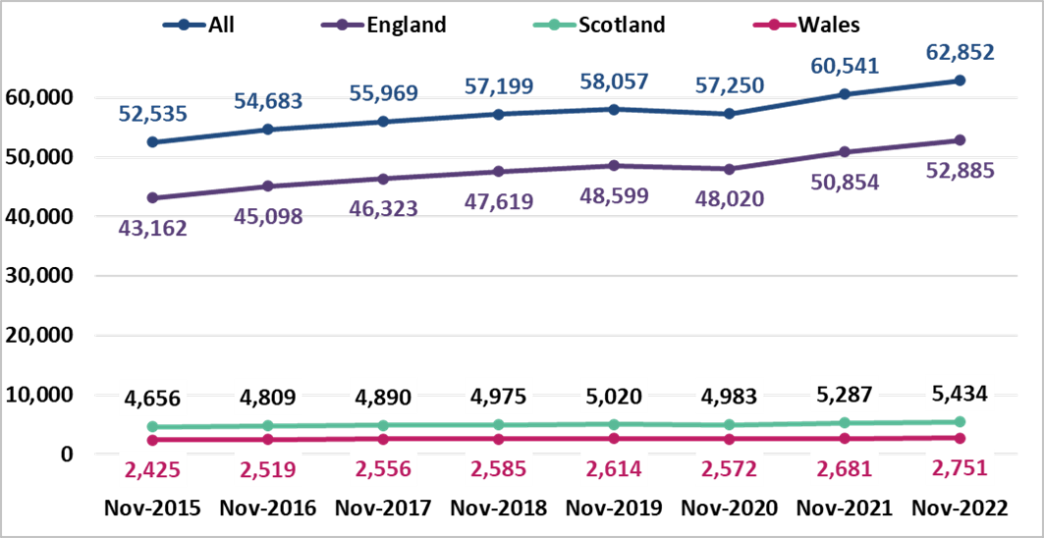

Annotations to the pharmacist register
On 30 November 2022, the number of registered pharmacists having a prescriber annotation has increased by 221 since the last month to 15,116 out of 62,852, this is 24% of the register. These include 13,927 independent prescribers only, 939 pharmacists who hold both independent and supplementary prescribing annotations and 250 supplementary prescribers only.
The breakdown of prescriber annotation by country of registered address is summarised in Table 2 below for pharmacists on 30 November 2022. The category of ‘Other’ includes countries that are overseas, Isle of Man, Northern Ireland and the Channel Islands. We do not know how many pharmacists are currently employed or are practising with their prescribing annotation.
Table 2: Number of pharmacists with prescribing annotation type by country of registered address on 30 November 2022
Prescriber annotation type | England | Scotland | Wales | Other | All
Independent only | 11,521 | 1,594 | 747 | 65 | 13,927
Independent and supplementary | 621 | 257 | 54 | 7 | 939
Supplementary only | 156 | 79 | 10 | 5 | 250
Total | 12,298 | 1,930 | 811 | 77 | 15,116

Register trends for pharmacy technicians
Table 3 and Figure 2 below shows the trend in pharmacy technician numbers on our register on 30 November from 2015 to 2022. This shows the register has been increasing year on year. There is a 1% increase from 24,964 in November 2021 last year to 25,279 in November 2022 this year. The number of pharmacy technicians has increased by 70 since the last month from 25,209 in October 2022.
Table 3: Snapshot of pharmacy technicians on the register by country of registered address
Snapshot date | All | England | Scotland | Wales
30 November 2022 | 25,279 | 21,030 | 2,374 | 1,709
30 November 2021 | 24,964 | 20,797 | 2,302 | 1,701
30 November 2020 | 24,268 | 20,226 | 2,228 | 1,658
30 November 2019 | 23,681 | 19,728 | 2,178 | 1,618
30 November 2018 | 23,537 | 19,612 | 2,120 | 1,642
30 November 2017 | 23,623 | 19,709 | 2,107 | 1,646
30 November 2016 | 23,457 | 19,561 | 2,092 | 1,634
30 November 2015 | 23,109 | 19,248 | 2,065 | 1,625
For Figure 2 below, the top teal blue line represents the total number of pharmacy technicians on the register. The dark purple line is England, the green line is Scotland, and the pink line is Wales. The overall proportion of pharmacy technicians in each country has remained steady as the numbers increased over the last eight years.
Figure 2. Snapshot of pharmacy technicians at the end of November by year and registered address location
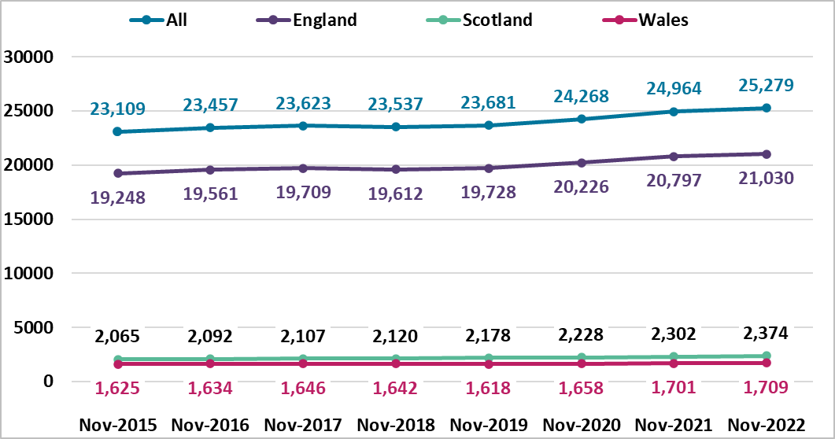

Register trends for pharmacies
On 30 November 2022 there were 13,811 registered pharmacies. 11,784 are in England, 1,301 in Scotland and 726 in Wales. This is a decrease of 124 from the same time last year, a fall of 0.9%. Table 4 shows a decrease each year. The numbers vary each month, with a decrease reported last month of 7, and a decrease of 26 from 13,837 in October 2022.
Table 4: Snapshot of all pharmacies on the register and by country of registered address at the end of November for the last eight years
Snapshot date | All | England | Scotland | Wales
30 November 2022 | 13,811 | 11,784 | 1,301 | 726
30 November 2021 | 13,935 | 11,900 | 1,303 | 732
30 November 2020 | 14,004 | 11,970 | 1,298 | 736
30 November 2019 | 14,247 | 12,209 | 1,299 | 739
30 November 2018 | 14,320 | 12,280 | 1,295 | 745
30 November 2017 | 14,403 | 12,369 | 1,290 | 744
30 November 2016 | 14,400 | 12,366 | 1,286 | 748
30 November 2015 | 14,468 | 12,419 | 1,297 | 746
For Figure 3 below, the top teal blue line represents the total number of pharmacies on the register. The dark purple line is England, the green line is Scotland, and the pink line is Wales. The overall proportion of pharmacies in each country has remained steady.
Figure 3. Snapshot of pharmacies on the register at the end of November each year by registered address location
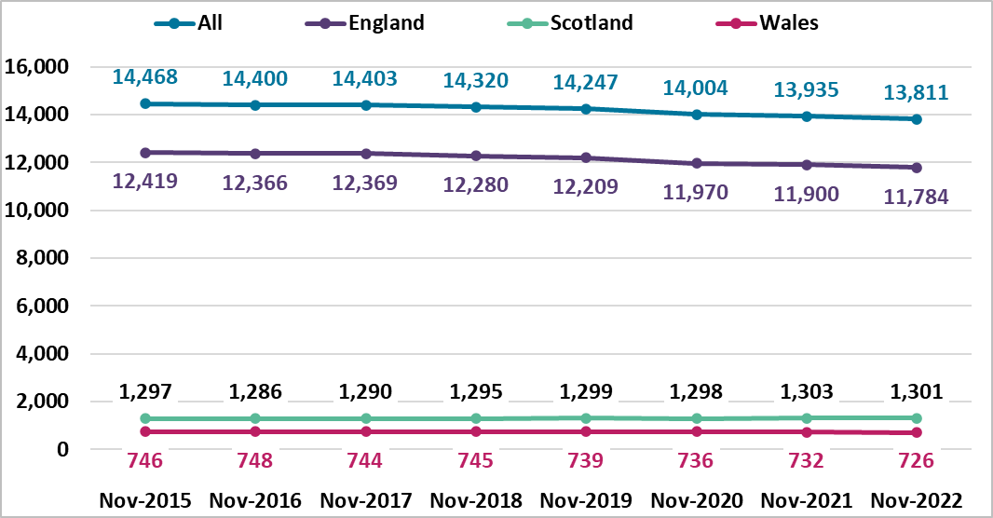

Annotations are additional qualifications or responsibilities held by a registrant. An independent prescriber can prescribe any medicine for any condition (excluding 3 Controlled Drugs for the treatment of addiction). A supplementary prescriber can prescribe any medicine for any condition within an agreed clinical management plan.

