The GPhC register as of 30 September 2022 - Trend data

Contents
Our register 1
How to interpret our data 1
Overall register headlines 1
Register trends for pharmacists 1
Annotations to the pharmacist register 3
Register trends for pharmacy technicians 3
Register trends for pharmacies 4

Our register
We maintain a comprehensive, fully up-to-date pharmacy register of all pharmacists, pharmacy technicians and pharmacy premises. We will make sure that no-one can be identified from any data that we publish or share with others.

How to interpret our data
Our permanent register can change daily and at different times of the day. The data presented here is a snapshot of our register at 23:59:59 on the dates specified.
Please note that numbers by country are according to their registered home address. This does not necessarily mean that registrants are working in those countries or that they are in employment. This only shows that they are on the register. Where tables or figures refer to ‘All’ countries, this includes registrants with a registered address in England, Scotland, Wales, Northern Ireland, Channel Islands, Isle of Man and Overseas. Where tables refer to ‘Other’ countries, these are all countries outside of Great Britain.
The numbers of pharmacists with a prescribing annotation does not reflect how many are currently employed or working with their prescribing annotation.
We continually review our data quality and content of our information to include the most accurate calculations. For improved data, we retrospectively update figures. This means when comparing this data with previously published data, you may see small changes.

Overall register headlines
- On 30 September 2022, the total number of pharmacy professionals on the register increased by 326 to 87,968 from 87,642 at the end of August 2022. The split by profession type remains steady with 71% pharmacists (62,834) and 29% pharmacy technicians (25,134). There was an increase in the number of pharmacists on register by 310 from 62,524 at the end of August 2022. The number the number of pharmacy technicians increased slightly by 16 from 25,118.
- The number of pharmacists with a prescribing annotation has increased by 301 from 14,327 on 31 August 2022 to 14,628 on 30 September 2022. This represents 23.2% of registered pharmacists where the overall proportion has remained steady.
- There are 13,844 registered pharmacies on 30 September 2022, a decrease of two from 13,846 in the last month on 31 August 2022. The numbers of pharmacies have been falling over the last eight years with a low of 13,843 pharmacies in April 2022, where numbers are fluctuating on a monthly basis.

Register trends for pharmacists
On 30 September 2022 the number of pharmacists on the register was 62,834. This is an increase of 1,424 from 61,101 at the end of August 2022. Table 1 shows the trend in the snapshot of pharmacist numbers on our register over time by location of registered address up to the end of 30 September each year for a direct comparison due to monthly variations.

Table 1: Snapshot of pharmacists on the register by location of registered address
Snapshot date | All | England | Scotland | Wales
30 September 2022 | 62,834 | 52,883 | 5,444 | 2,760
30 September 2021 | 59,388 | 49,819 | 5,231 | 2,648
30 September 2020 | 57,369 | 48,105 | 4,981 | 2,586
30 September 2019 | 57,918 | 48,451 | 5,022 | 2,611
30 September 2018 | 57,076 | 47,466 | 4,971 | 2,587
30 September 2017 | 55,775 | 46,139 | 4,880 | 2,556
30 September 2016 | 54,493 | 44,922 | 4,792 | 2,510
30 September 2015 | 52,138 | 42,778 | 4,640 | 2,418
Compared to the same time last year, there is 6% increase of pharmacists by 3,446 from 59,388 on 30 September 2021 to 62,834 on 30 September 2022. This percentage increase includes joiners to the register following the postponed registration assessments in 2020.
Of the 62,834 pharmacists, 1,747 (3%) have a registered address outside of Great Britain. These include recent joiners who have yet to register an address in Great Britain. Others have left Great Britain and are overseas but would like to retain their GPhC registration or have yet to leave the register.
In Figure 1, the top teal blue line represents the total number of all pharmacists on the register at the end of each month of September (including those with a registered address in England, Scotland, Wales, Northern Ireland, Channel Islands, Isle of Man and overseas). The dark purple line are the figures for England, the green line is for Scotland and the pink line is for Wales.
Figure 1: Snapshot of pharmacists on the register at the end of September each year by registered address location
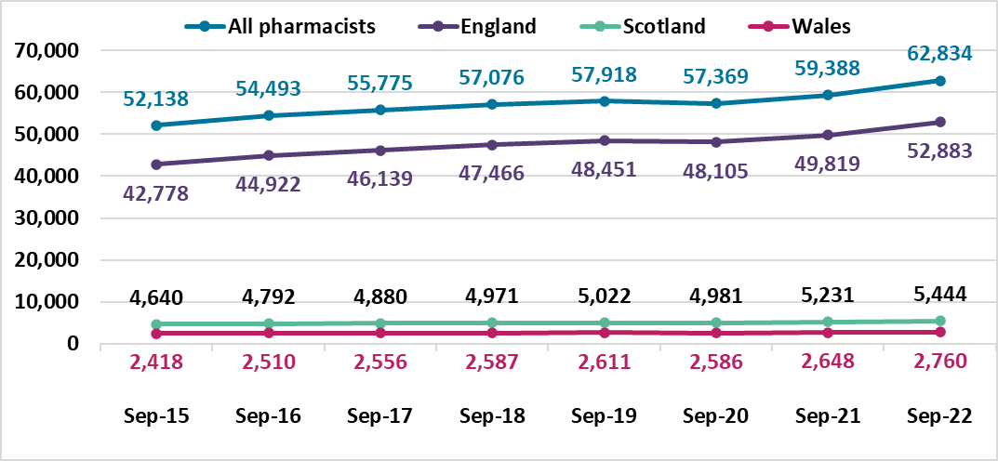

Annotations to the pharmacist register
On 30 September 2022, the number of registered pharmacists having a prescriber annotation has increased by 301 since the last month to 14,628 out of 62,834, this is 23.3% of the pharmacist register. These include 13,436 independent prescribers only, 937 pharmacists who hold both independent and supplementary prescribing annotations and 255 supplementary prescribers only.
The breakdown of prescriber annotation by country of registered address is summarised in Table 2 below for pharmacists on 30 September 2022. The category of ‘Other’ includes countries that are overseas, Isle of Man, Northern Ireland and the Channel Islands. We do not know how many pharmacists are currently employed or are practising with their prescribing annotation.
Table 2: Number of pharmacists with prescribing annotation type by country of registered address on 30 September 2022
Prescriber annotation type | England | Scotland | Wales | Other | All
Independent only | 11,115 | 1,528 | 734 | 59 | 13,436
Independent and supplementary | 621 | 255 | 55 | 6 | 937
Supplementary only | 158 | 82 | 10 | 5 | 255
Total | 11,894 | 1,865 | 799 | 70 | 14,628

Register trends for pharmacy technicians
Table 3 and Figure 2 below shows the trend in pharmacy technician numbers on our register on 30 September from 2015 to 2022. This shows the register has been increasing year on year. There is a 1% increase from 24,962 in September 2021 last year to 25,134 in September 2022 this year. The number of pharmacy technicians has increased by 16 since the last month from 25,118 in August 2022.
Table 3: Snapshot of pharmacy technicians on the register by country of registered address
Snapshot date | All | England | Scotland | Wales
30 September 2022 | 25,134 | 20,899 | 2,360 | 1,705
30 September 2021 | 24,962 | 20,792 | 2,287 | 1,712
30 September 2020 | 24,035 | 20,000 | 2,225 | 1,652
30 September 2019 | 23,644 | 19,676 | 2,185 | 1,627
30 September 2018 | 23,490 | 19,578 | 2,109 | 1,642
30 September 2017 | 23,520 | 19,620 | 2,102 | 1,637
30 September 2016 | 23,396 | 19,494 | 2,096 | 1,635
30 September 2015 | 22,997 | 19,159 | 2,056 | 1,611

For Figure 2 below, the top teal blue line represents the total number of pharmacy technicians on the register. The dark purple line is England, the green line is Scotland, and the pink line is Wales. The overall proportion of pharmacy technicians in each country has remained steady as the numbers increased over the last eight years.
Figure 2. Snapshot of pharmacy technicians at the end of September by year and registered address location
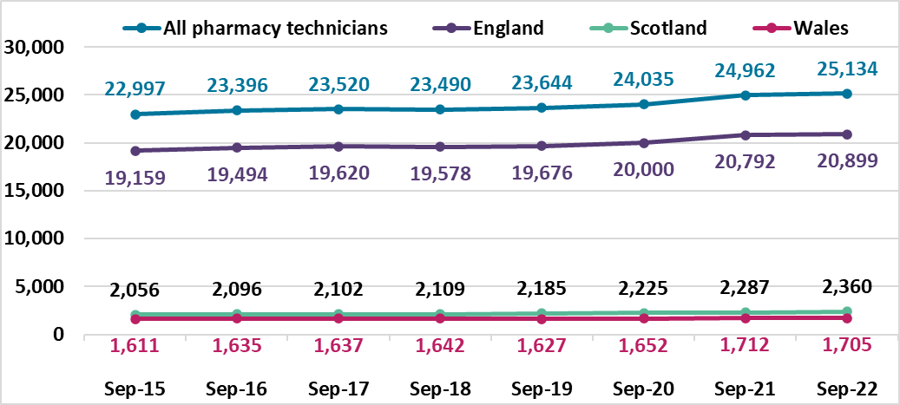

Register trends for pharmacies
On 30 September 2022 there were 13,844 registered pharmacies. 11,816 are in England, 1,303 in Scotland and 725 in Wales. This is a decrease of 114 from the same time last year, a fall of 0.8%. Table 4 shows a decrease each year. The numbers vary each month, with an increase reported last month, but in this month, there was a decrease of two from 13,846 in August 2022.
Table 4: Snapshot of all pharmacies on the register and by country of registered address
Snapshot date | All | England | Scotland | Wales
30 September 2022 | 13,844 | 11,816 | 1,303 | 725
30 September 2021 | 13,958 | 11,922 | 1,302 | 734
30 September 2020 | 14,045 | 12,012 | 1,297 | 736
30 September 2019 | 14,259 | 12,219 | 1,300 | 740
30 September 2018 | 14,323 | 12,285 | 1,293 | 745
30 September 2017 | 14,398 | 12,370 | 1,285 | 743
30 September 2016 | 14,420 | 12,387 | 1,284 | 749
30 September 2015 | 14,457 | 12,410 | 1,300 | 747
For Figure 3 below, the top teal blue line represents the total number of pharmacies on the register. The dark purple line is England, the green line is Scotland, and the pink line is Wales. The overall proportion of pharmacies in each country has remained steady.
Figure 3. Snapshot of pharmacies on the register at the end of September each year by registered address location
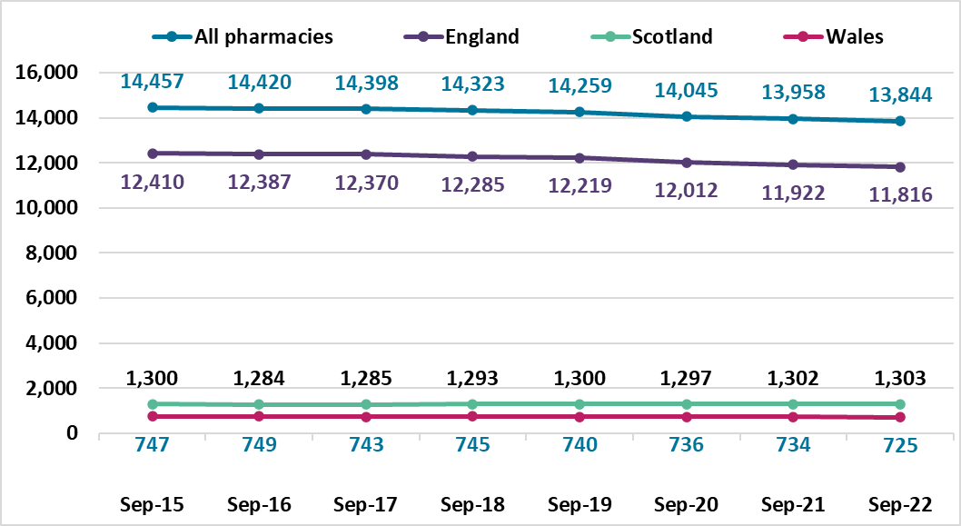

Annotations are additional qualifications or responsibilities held by a registrant. An independent prescriber can prescribe any medicine for any condition (excluding 3 Controlled Drugs for the treatment of addiction). A supplementary prescriber can prescribe any medicine for any condition within an agreed clinical management plan.

